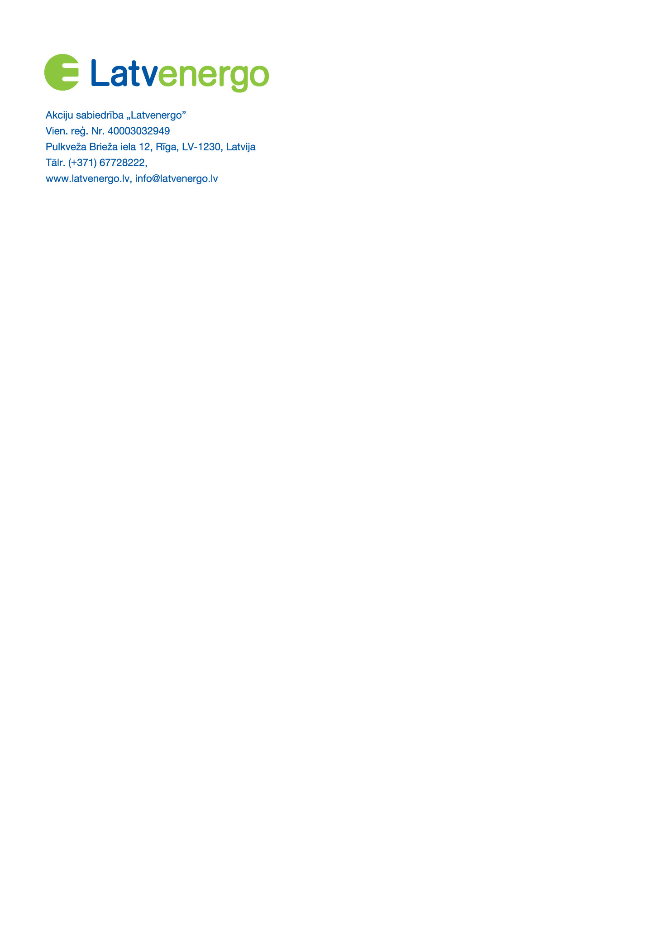

Public Limited Company Latvenergo
Unified Reg. No. 40003032949
Pulkveža Brieža iela 12, Riga, LV-1230, Latvia
Tel. (+371) 67728222
www.latvenergo.lv, info@latvenergo.lv

REFUSAL FORM
(Fill in and send this form only if you want to cancel the distance purchase agreement)
Date . . .
USE CAPITAL LETTERS ONLY TO FILL OUT THE FORM
NAME, SURNAME
OF THE BUYER:
ADDRESS OF THE BUYER: |  |  | LV-
CONTACT INFORMATION OF THE BUYER: | Telephone/mobile phone: | E-mail address:
I hereby declare that I would like to exercise the consumer's right of refusal and refuse the products purchased at Latvenergo AS Energy Museum:
PRODUCT NAME,  PRICE,  NUMBER OF UNITS,  DATE OF PURCHASE/RECEIPT | 1.
 | 2.
 | 3.
 | 4.
 | 5.
Document confirming the purchase of the PRODUCT:
I hereby inform you that I would like to exercise the consumer's right of refusal under Section 12 of the Consumer Rights Protection Law and cancel the PRODUCT purchase agreement.

Please submit the completed refusal form together with a copy of the proof of purchase in one of the following ways:
- by sending to the e-mail muzejs@latvenergo.lv
- by sending by mail to the address: Latvenergo AS Energy Museum, Ķeguma prospekts 7/9, Ķegums, Ogre Municipality, Latvia, LV-5020
- by submitting in person at the Latvenergo AS Energy Museum, Ķeguma prospekts 7/9, Ķegums, Ogre Municipality, Latvia, LV-5020
After sending the refusal form, please send or deliver the PRODUCT(S) to Latvenergo AS Energy Museum within 14 (fourteen) days. The PRODUCT(S) can be sent or delivered at Latvenergo AS Energy Museum, Ķeguma prospekts 7/9, Ķegums, Ogre Municipality, Latvia, LV-5020.

By signing this form, I certify that:
- I have read the terms and conditions governing the right of refusal and the information of Latvenergo AS Energy Museum on the exercise of the right of refusal, including the fact that the direct costs related to the return of the PRODUCT(S) are borne by the BUYER.
- I am informed and aware that Latvenergo AS shall process the personal data indicated in the form in order to achieve the purposes indicated in the form. Additional information on the processing of personal data is available in the document “Principles of Personal Data Processing, Ensuring the Availability of Latvenergo Group Energy Museum”, which is available on the website of Latvenergo AS https://latvenergo.lv/lv/par-mums/personas-datu-apstrades-principles or by receiving the printed document at the specified address upon request.
. . . __________________________
(date) (signature if the form is submitted on paper) (printed name)

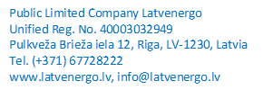

INFORMATION ON THE EXERCISE OF THE RIGHT OF REFUSAL IN THE EVENT OF PURCHASE OF THE PRODUCT
1. As a consumer who has purchased the PRODUCT on the online purchase platform of Latvenergo AS Energy Museum for electronic tickets, services and products (hereinafter - the E-store), you may cancel the distance purchase agreement within 14 (fourteen) days without giving a reason. The right of refusal expires after 14 (fourteen) days from the date you have received the purchased PRODUCT in your possession.
2. In order to exercise the right of refusal, you shall by means of an unambiguous statement containing information identifying you (name, surname, e-mail address) and information about the purchased product (name, price, number, date of purchase/receipt), inform Latvenergo AS Energy Museum of the decision to cancel the distance agreement for the purchase of PRODUCTS. You can use the attached REFUSAL FORM or submit a free-form notice on the exercise of the right of refusal.
3. A notice regarding the exercise of the right of refusal together with the document confirming the purchase, may be submitted to Latvenergo AS Energy Museum in the following ways:
- by sending to the e-mail muzejs@latvenergo.lv
- by mail: Latvenergo AS Energy Museum, Ķeguma prospekts 7/9, Ķegums, Ogre Municipality, Latvia, LV-5020
- by submitting in person at Latvenergo AS Energy Museum, Ķeguma prospekts 7/9, Ķegums, Ogre Municipality, Latvia, LV-5020.
4. The right of refusal will be deemed to have been complied with if you submit your notice on the exercise of the right of refusal before the expiry of the right of refusal.
5. The PRODUCT must be returned to Latvenergo AS Energy Museum no later than within 14 (fourteen) calendar days from the day you announced the exercise of the right of refusal. The PRODUCT can be sent to Latvenergo AS Energy Museum, which is located at: Ķeguma prospekts 7/9, Ķegums, Ogre Municipality, Latvia, LV-5020, or the PRODUCT can be delivered at Latvenergo AS Energy Museum upon arrival in person. The deadline will be met if you send or deliver the PRODUCT before the expiry of the 14 (fourteen) day period. Please note that you will have to bear the direct costs of returning the PRODUCT.
6. The PRODUCT you return must be undamaged, in perfect visual condition and unused. You are only liable for the depreciation of the PRODUCT if the PRODUCT has been used for purposes other than determining the nature, characteristics and functioning of this PRODUCT.
7. If you exercise the right to cancel the distance agreement for the purchase of the PRODUCT, Latvenergo AS will refund all payments received from you for the PRODUCT without undue delay and in any case no later than within 14 (fourteen) days from the date when Latvenergo AS was informed of your decision to cancel the distance agreement for the purchase of the PRODUCT.
8. Refund will be made using the same means of payment you used for the original transaction, unless you have expressly agreed on another procedure. You will not be charged for such a refund.
9. Latvenergo AS may withhold a refund until it has received the PRODUCT back or until you have provided proof that the PRODUCT has been returned, whichever comes first.
10. Please be advised that in accordance with Paragraph 22.12 of Cabinet Regulation No. 255 adopted on 13 June 2014 “Regulations Regarding Distance Contracts”, the right of refusal, indicated in the Consumer Rights Protection Law, permitting unilateral withdrawal from the purchased service within 14 days if the E-ticket and/or service is purchased using a distance agreement (online), is not applicable to the purchase of Latvenergo AS Energy Museum e-tickets and services.

