Annex 2: Technical specification

Ordered research work task

1. Title of work
Building design in minimum composition for the installation of a stationary electric battery storage system for installation at the Riga HPP territory site.
2. Purpose of the work
To develop a building design in the minimum composition (preliminary design) for the installation of a stationary electric battery energy storage system (BESS – Battery Energy Storage Systems) in the territory of the production plant Riga hydro power plant (hereafter - HPP). Within the building design it is necessary to clarify BESS technical parameters and technological solutions, to evaluate BESS connection and installation sites in the Riga HPP area, assess building work volumes and environmental impact, BESS connection conditions and costs at 13.8 kV busbars and other engineering communications, compile building project estimates and prepare documentation for the transmission system operator's (hereafter - TSO) technical rules and documentation for obtaining a building permit from the building authority.
3. Justification
Due to the synchronization of the Baltic power systems with the Continental European system, Latvenergo AS (hereafter - Latvenergo) will have the opportunity on a larger scale to provide electricity reserve products to the operators of the transmission system of the Baltic Sea region to ensure the system's balancing needs. Primarily, TSOs will need frequency containment and restoration reserves (FCR and aFRR). In addition to Latvenergo's existing power plants, battery storage is being considered as one of the technological solutions to ensure FCR. BESS is one of the fastest growing technologies for electricity storage. Due to their fast response times, their power capacity is increasingly used in the ancillary services markets for frequency regulation, including the provision automatic frequency restoration reserves (aFRR). In addition, electric batteries can be used for several other grid services such as peak load balancing, balancing intermittent power generation (solar and wind power), voltage stability, for compensating the unwanted effects of power and frequency regulation of hydro units, black start, etc.

4. Information about the object
Riga HPP is the newest Daugava hydroelectric power station and the second largest power station in Latvia. It was built from 1966 to 1974 and is located 35 km from the river mouth. The maximum head of HPP is 18 meters. The hydropower station is equipped with six hydro units with "Kaplan" turbines. The reconstruction of the last hydro unit was completed in 2022, while the reconstruction of the first hydro unit was completed in 2018. The total installed capacity of the hydro units of the power station is 402 MW. Apart from the production of electricity, the hydro units of the Riga HPP can also be operated in the synchronous compensator mode, they can participate in the regulation of the voltage and frequency of the electricity system. The main parameters of electrical equipment are listed in Table 1.
Table 1. Riga HPP basic equipment and their main parameters
No. | Nominal characteristics | Value
1. | Turbine type | Vertical, Kaplan
2. | Turbine capacity at nominal head | 69 MW
3. | Nominal active capacity of the generator | 67 MW
4. | Rated capacity | 75,3 MVA
5. | Power factor (Cosφ) | 0,89
6. | Nominal head | 16,5 m
7. | Nominal speed | 55,5 turns/min.
8. | Frequency | 50 Hz
9. | Direction of rotation | Clockwise direction
10. | Nominal pressure of oil pressure equipment | 160 bar
11. | Nominal voltage of the generator stator | 13,8 kV
12. | Generator stator nominal current | 3150 A
13. | Generator flywheel moment | ​57000 GD²
14. | Generator inertia constant | 3.19 H
15. | Kinetic energy stored by the generator | 240.5 MW*s
16. | Number of poles | 108
17. | Stator weight | 236 t
18. | Rotor weight | 430 t
19. | Water flow in the hydro unit at the calculated head and capacity | 500 m³/s

5. Information on the planned project
5.1. BESS technological solutions and indicative parameters
It is necessary to specify possible technological solutions and BESS technical parameters for ensuring frequency reserves in all balancing markets, ensuring FCR and aFRR.
Three types of reserves are planned to be used in the Baltics Load-Frequency Control (hereafter - LFC) block - FCR, aFRR (automatic), mFRR (manual) and the so-called imbalance netting process (TSOs platform). According to a common Baltic methodology, the necessary reserves for each TSO of the Baltic countries were assessed and distributed among the countries. On October 21, 2022, at the informal seminar "Electricity Market Forum", JSC "Augstsprieguma tīkls" reported on the amount of FCR required for the Baltic States ±25 MW (of which 12 MW is the amount of PSO/BSO to cover reserves), an upward aFRR amount of 134 MW (of which 65 MW is the amount of TSO/BSO to cover reserves) and downward aFRR amount of 134 MW (of which 65 MW is the amount of TSO/BSO to cover reserves). The extent of FCR and aFRR is reviewed annually. Reserve ensuring entities will undergo a technical compliance assessment before they can participate in the balancing markets:
- Baltic balancing energy market;
- mFRR in the balancing energy platform MARI;
- aFRR balancing energy platform PICASSO;
- Latvia's safety reserves in procurement and auctions;
In the Baltic balancing capacity market.

The FCR service must be able to be fully activated within 30 seconds if the local frequency deviation is at least +/- 200 mHz. Traditionally, FCR has been provided by thermal power plants when those are in rotating state, however, more and more often these types of reserves are also being provided by a stationary BESS. Considering the technical characteristics of different battery technologies, as well as the trends in the development and use of those technologies, the Latvenergo pre-feasibility study considered lithium-ion batteries for the provision of FCR services.
According to Commission regulation 2017/1485 establishing a guideline on electricity transmission system operation requirements, both upward and downward FCR must be provided for at least 15 minutes. This criterion imposes limits on the SOC (State of Charge) operating range of the BESS. In order to meet the above 15 minutes criterion in both directions, as well as the allowable SOC levels, a minimum battery electric energy rating of 20 MWh has been chosen. Furthermore, the normal state of charge (SOCnorm) of the BESS should be kept close to 50% to guarantee full availability of the BESS for FCR both up and down regulation. If BESS were also used to provide aFRR, the minimum battery energy capacity would be even higher.
On 21 January 2021, an updated Baltic LFC block concept document was published on the JSC "Augstsprieguma tīkls" website, which, among other things, provides information for the development of common qualification conditions for resources to be used for FCR and FRR needs. The conditions for evaluating the technical compliance of Baltic LFC reserve suppliers were published on March 21, 2022. The Baltic TSOs plan to establish national rules for the assessment of the technical compliance of LFC reserve providers in accordance with the common Baltic conditions, and to start qualifying LFC reserve providers already in 2023.
5.2. BESS location options for the Riga HPP site
The potential sites for BESS placement at the Riga HPP are located on the left bank in the adjacent territory (Figure 1). Territory can be subdivided into at least 18 plots with an area of 625 m² each (total area 11,250 m²)
Figure 1. BESS sitting options on the territory of Riga HPP
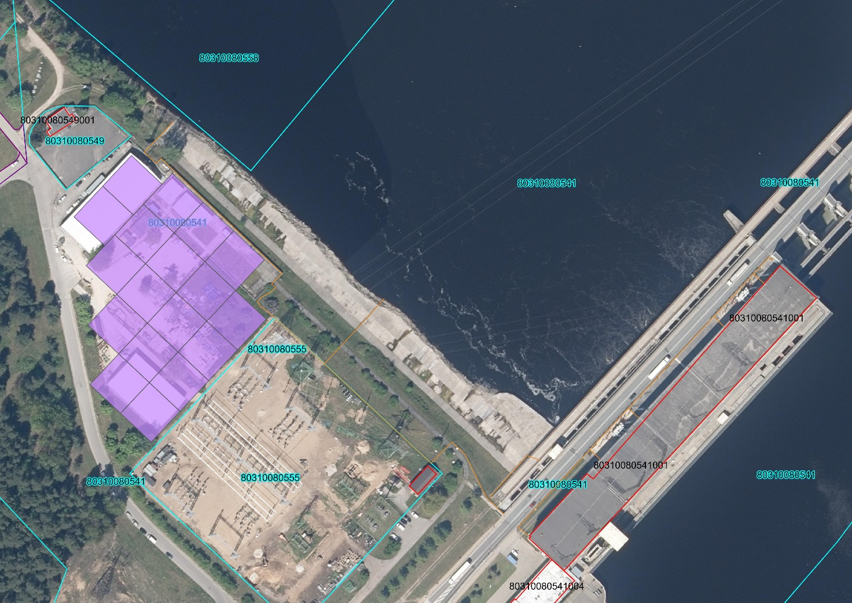
BESS coonection zone Nr.1
BESS placement zone
BESS connection place Nr.2
2

When evaluating a BESS installation site, it is essential to be aware of the Riga HPP capacity utilization, as self-consumption costs when the power plant is in operation are lower than when the plant receives electricity from the grid.
The possible BESS connection point is shown in Figure 2 - "Riga HPP building cross-section".

Figure 2. Cross-section of the Riga HPP building

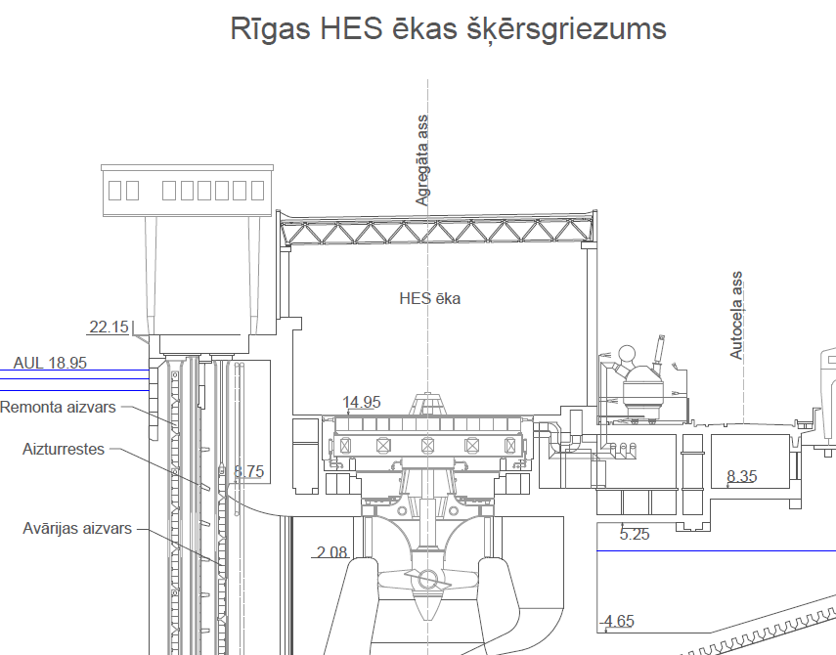
BESS connection place

On the other hand, Figure 3 shows the arrangement of hydro units and bus lines on the elavation mark 8.35 m.

Figure 3. Location of hydro units and bus lines on elavation mark 8.35 m.
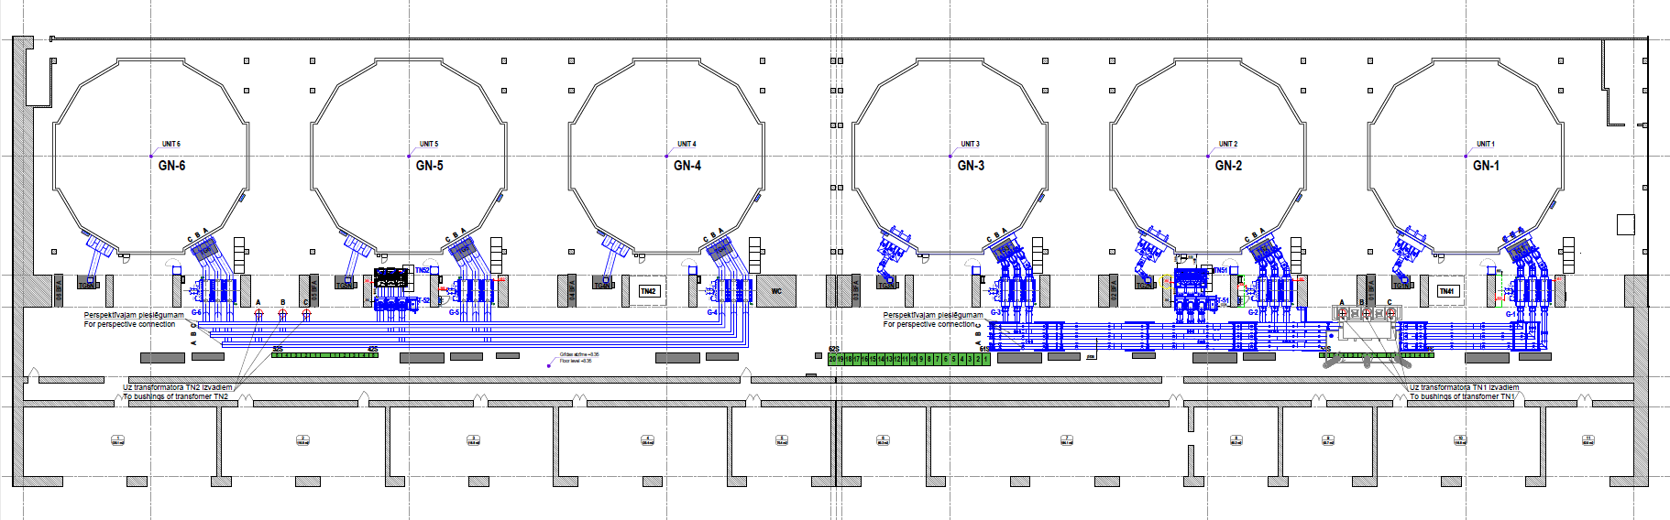
Not only the costs for BESS operation, but also the provision of the entire BESS complex, including microclimate control equipment (HVAC - heating, ventilation and air conditioning), must be taken into account. It is essential to be aware of all additional costs for BESS installation, such as the construction of additional communications, and take them into account when evaluating different installation locations.
5.3. BESS connection to the 13.8 kV busbars of Riga HPP
It is possible to connect the BESS to the 13.8 kV busbars by expanding them, but due to the large short-circuit currents in the busbar, three generators in one block, the connection must be implemented by installing an additional three-phase short-circuit current limiting reactor and an additional circuit breaker. The contractor must perform calculations to justify solutions for short-circuit current limitation. (note: the contractor will have access to the results of the SWECO study, where the initial assessment has been made, but the contractor need to check this assessment). The technical data sheet of 13.8 kV busbars will be available to the contractor (see attachment).
Both the existing and the new ones to be installed (replacement of the existing transformers) step-up block transformers (TN1 and TN2) will have a capacity of 250 MVA (each) and considering that 3 hydro units (total 225.9 MVA) are connected to each transformer, an additional ~20 MVA connection is possible at points TN1 and TN2 (see Figure 4).
Figure 4. BESS connection diagram for Riga HPP plant busbars

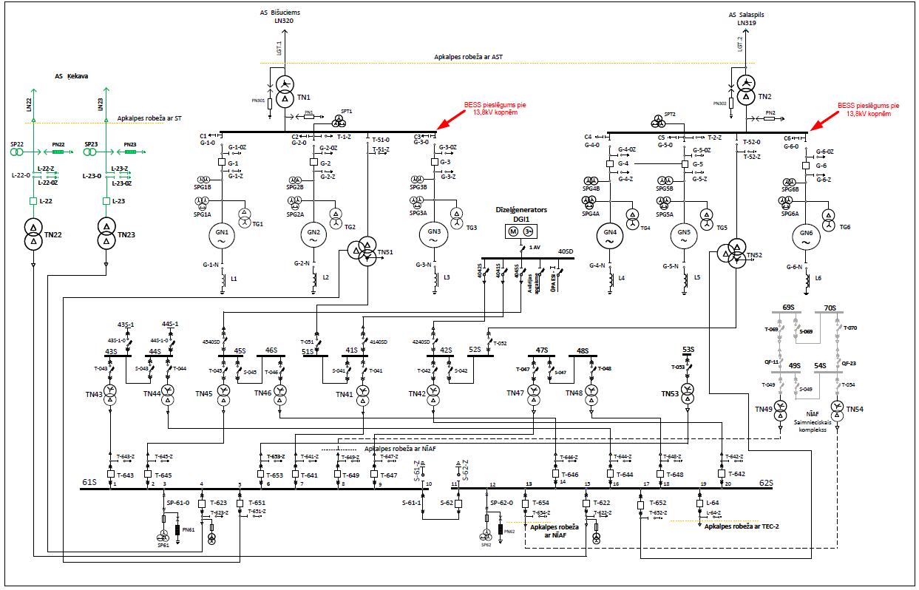

5.4. Attracting co-financing.
Given the importance of the BESS project for the stability of electricity supply in Latvia and the Baltic region, it is appropriate to attract co-financing from the European Union. At the feasibility stage of the project, it would be most advantageous to apply for funding from the European Structural and Investment Funds. In the construction phase of the project, the Modernization Fund could be the most advantageous. In the construction phase, another source of funding could be the European Innovation Fund, which launches calls for innovative large and small projects (CAPEX > or < EUR 7.5 million, respectively).
One of the objectives of this work is to prepare the necessary documentation and demonstrate the project's readiness for EU co-financing.
To be eligible for funding from the Innovation Fund, a project must have innovative solutions. Contractors need to consider the feasibility of incorporating innovative solutions in the scope of work.
BESS is planned to be connected to the Riga HPP production plant. Electricity from the Riga HPP is expected to be used to restore its state of charge. When the hydro-units are at work, the electricity produced by the hydro-units (renewable energy source) must be used to restore the charging state, and when the hydro-units are not at work - from the electric network.
To be eligible for funding from the Innovation Fund, a project must have innovative solutions. Contractors need to consider the feasibility of incorporating innovative solutions in the scope of work.
6. Scope of work
6.1. Develop requirements for the technical solution of a stationary electric battery energy storage system (BESS):
- determine the technical parameters of the BESS (nominal power, energy capacity, actual available electricity, normal, minimum and maximum state of charge (SOC) level, total efficiency of BESS, system and component efficiency factors, annual degradation, availability, duration of operation, working life, etc.) in accordance with the requirements of the Latvian transmission system operator;
- provide an overview of the BESS components (energy storage modules, inverters, automatic control systems, SCADA, electrical switchgear, transformer, HVAC, relay protection);
- provide recommendations on technical solutions, determine technical and other requirements, develop technical specifications for the next procurement of BESS for delivery and installation;
- provide recommendations regarding the organization of equipment supplier tender, including possible tender participants who should be approached personally

6.2. Choice of construction site:
- choose BESS construction site within the proposed plot of land (site in Figure 1). An alternative siting option may be proposed;
- the following criteria must be taken into account when assessing the construction sites: availability and sufficiency of free land, geology, connection costs to Riga HPP and other engineering communications, preparation costs of construction site;
- provision of earthing and lightning protection systems in accordance with building codes and standards;
- provide fire protection systems in accordance with international standards, local norms and experience of working with the specific BESS technology;
- evaluate the compliance of the BESS with noise level requirements, taking into account the noise level generated by the operation of the equipment to be installed;
- evaluate possible places for BESS connection, installation of reactors, switchgear, laying of cables.

6.3. Assessment of the construction works:
- provide an overview of the expected construction works, i.e. presenting the related works (development of the building project, development of the work execution project, submission of executive documentation and commissioning of the facility);
- Estimate construction costs.

6.4. BESS connection to Riga HPP:
- consider connection to the RHPP electrical system;
- provide all necessary electrical equipment for the implementation of the project - three-phase short-circuit current limiting reactor, or other technical solution for short-circuit current limiting, gauges, power switches, circuit breakers, transformers and others that may be necessary, as well as evaluate the modification of existing equipment, for example 13.8 kV busbars extension;
- evaluate the storage of all necessary electrical equipment, including from the point of view of the bearing capacity of the structures and overall dimensions of the equipment, and the remaining space on the elavation mark 8.35 m in the HPP production premises;
- provide the electrical equipment necessary for the self-consumption of the BESS system and their connection to the existing equipment of the Riga HPP and, if necessary, the modification of the existing system (i.e. equipment replacement);
- calculations must be performed to justify solutions for limiting the short-circuit current. (Note: the contractors will have access to the results of the SWECO study, where the initial assessment has been made, but the contractors need to check this assessment);
- provide all the necessary DC and AC cables that ensure the lowest possible losses and the highest possible charging/discharging efficiency, as far as it is economically justified;
- provide control of BESS from the Riga HPP main control room, integrating it into the existing control system of RHPP, including parallel and coordinated operation of BESS and RHPP generators;
- provide all necessary management, control, fire protection and electronic communication cables;
- provide surge protection;
- check the adequacy of existing transformer's capacity and cable throughput for BESS connection;
- perform other necessary calculations of electrical parameters (short-circuit currents, voltage losses, etc.);
- choose relay protection and its operating parameters, ensuring that disturbances in the BESS and its connection do not cause outages of RHPP generators or step-up transformers, as well as meet the requirements of the transmission system operator;
- evaluate the possible cable lines from the connection point to the BESS, as well as the construction possibilities of cable lines, if the existing cable tunnels do not provide enough space for the construction of new lines in them;
- provide electricity metering;
- create a BESS electricity self-consumption scheme.

6.6. Preparation of BESS construction project capital and operating cost assessment:
- provide evaluation of project capital cost estimates (CAPEX);
- assess operating costs (OPEX) of the BESS.

6.7. Preparation of documentation for receiving technical rules and building permits:
- prepare and submit documentation to the transmission system operator (AS Augstsprieguma tīkls) for the receipt of technical rules;
- prepare building design in the minimum composition and submit it to the local building authority in the construction information system (BIS), for receiving building permits and design conditions, including technical regulations.

7. Executive documentation
7.1. The original of the project report in paper format (one copy) and in electronic format (PDF) in Latvian or English.
7.2. Original project summary in paper format (one copy) and electronic format (PDF) in Latvian or English.
7.3. The graphic part of the project in paper format (one copy) and electronic editable format (DWG) in Latvian or English.
7.4. Building design in minimum composition in paper format (latvian language, one copy) and one copy in electronic format (PDF).
7.5. The project report and summary must be submitted in *.pdf and *.doc form (the entire report in one file) and the graphic part in editable DWG format on an electronic data carrier (e.g. CD, DVD or USB).
7.6. The project documentation must be developed in accordance with the requirements established in the European Union, as the project is intended to be submitted to the EU or Latvian program for receiving co-financing.
7.7. The documentation must be drawn up in accordance with the regulatory enactments in force in Latvia and the internal procedure of the Customer JSC "Latvenergo" K162 "Procedures for the drawing up, transfer and use of technical documentation in the technical archives of the technical management functions of HPP". Binding documents for contractors can be viewed: https://latvenergo.lv/lv/par-mums/saistosie-dokumenti-darbuznemejeim

8. Requirements for the Contractor who is carrying out the work
8.1. The contractor must comply with the requirements of Latvian legislation relating to the preparation of building design in the minimum composition.
8.2. The Contractor shall have the necessary designers' certificates in the relevant field of activity.
8.3. The Contractor must determine the technical parameters of BESS together with the Customer, in consultation with the transmission system operator (AS "Augstsprieguma tīkls").
8.4. While developing the BESS technical solution, consider work in the Continental Europe's electricity system, in accordance with the "CE Synchronous Area Framework Agreement" and in compliance with the requirements of the European Commission regulations (Network Codes and Guidelines).
8.5. When selecting the requirements of BESS basic equipment, ensure the most efficient operation both during small power fluctuations and the overall highest efficiency when working at full power.
8.6. When selecting the requirements of the BESS auxiliary systems, provide for the determination of their parameters, taking into account the actual operating conditions in the territory of the Riga HPP.
8.7. When selecting the requirements of the BESS control system, the possibility of operating the BESS for the provision of system services (primarily, FCR), as well as the ability to operate to achieve common power settings with existing Riga HPP generators, must be provided.
8.8. When developing the building design in the minimum composition, ordering engineering research (geodesic, topographical and geotechnical research) should be carried out only for the selected construction site, prior to this being coordinated with AS "Latvenergo".
8.9. During the development of the work, the Contractor must coordinate the main technical solutions and fundamental issues with the Contracting party.

9. Deadlines for work
9.1. The maximum time limit for completion of the work - 180 (one hundred and eighty) within calendar days from the date of signing the Agreement.
9.2. Deliverables to be submitted to the CONTRACTING PARTY as part of the execution of the work and estimated deadlines:
9.2.1. within 60 (sixty) days from the date of signing the Agreement, deliver Assignment No. 1, which includes the tasks referred to in clause 6.1;
9.2.2. within 120 (one hundred and twenty) days from the date of signing the Agreement, deliver Assignment No. 2, which includes the tasks referred to in clauses 6.2., 6.3, 6.4, and 6.5;
9.2.3. within 180 (one hundred and eighty) days from the date of signing the Agreement, submit a final report including the completion of the tasks referred to in clause 6.6.

Concept document - https://www.ast.lv/sites/default/files/editor/Baltic_Load_Frequency_Control_concept_document.pdf (viewed 31.01.2022)
https://www.ast.lv/lv/events/atjauninati-elektroenergijas-sistemas-slodzes-un-frekvences-kontroles-rezervju-piegadataju

