- Asset Pass

ASSET PASS
Asset movement is allowed:
Responsible person

(name of the facility)
(position, signature, name, surname)
. .20__.

Movement allowed: . .20__ .
No. | Name of the assets taken in  (or the number of the way-bill ) |  |  |  | unit | quantity
No. | Name of the assets taken out (or the number of the way-bill ) |  |  |  | unit | quantity
Asset owner: |  | Company name
 |  | Position, signature, name, surname
Taken in/out by:  (security – date, time, signature, name, surname) |  |  |  | Taken in/out by:  (security – date, time, signature, name, surname)
Vehicle:  Manufacturer State Reg. No.  Driver  (name, surname, personal ID code) |  |  |  | Vehicle:  Manufacturer State Reg. No.  Driver  (name, surname, personal ID code)

Asset Pass Card

Asset Pass Card is issued by the Pass Office. Asset Pass Card is prepared and printed on A4 size format in paper copy and laminated if necessary.
Issue date, expiration date, vehicle manufacturer and registration number, vehicle owner and vehicle driver, and the list of special equipment and tools necessary for execution of particular works shall be specified in the Asset Pass Card.

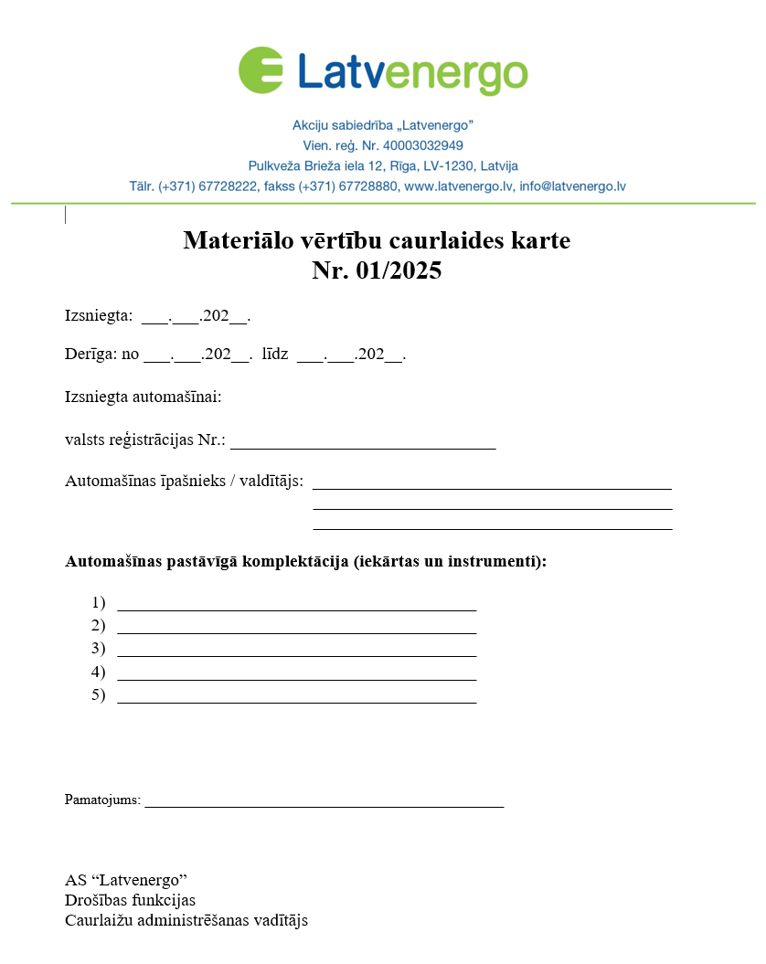
*The visual form of the material asset permit card is not intended for data submission.

